Health care analysis using pyspark df and rdd

Overview

PySpark exposes two core distributed abstractions:
RDD (Resilient Distributed Dataset)
Low-level, immutable distributed collections of records. Functional transformations (e.g., map, filter, flatMap) with explicit control over partitioning, storage levels, and combinations. Best for custom processing, iterative algorithms, and situations where you cannot model operations elegantly with the SQL API.
DataFrame
High-level, columnar, schema-aware API built on Spark SQL. Optimized by Catalyst (query optimizer) and Tungsten (vectorized execution and memory management). Best for analytics, joins, aggregations, window functions, SQL, and I/O. Offers Adaptive Query Execution (AQE) for dynamic optimizations.
Recommendation: Use DataFrames for most analytical workloads (performance + maintainability). Use RDDs when you need granular control or transformations outside the DataFrame semantics.
Set-up DataBricks:
- Sign up to Databricks community free edition portal
Upload file:
- Go to catalog and open add data. Browse files and select the file from internal device.
- Choose destination of the file. Put workspace as Default, and create a volume named “My_volume” by default it is managed volume and upload it.
- The file will be uploaded and copy the file path.
- You can verify the uploaded file: catalog a workspace default volume you can find the uploaded file.
DATA CLEANING
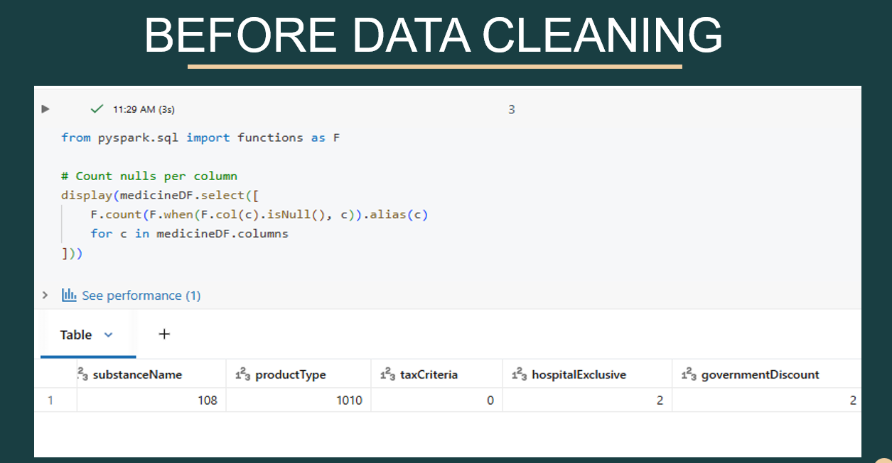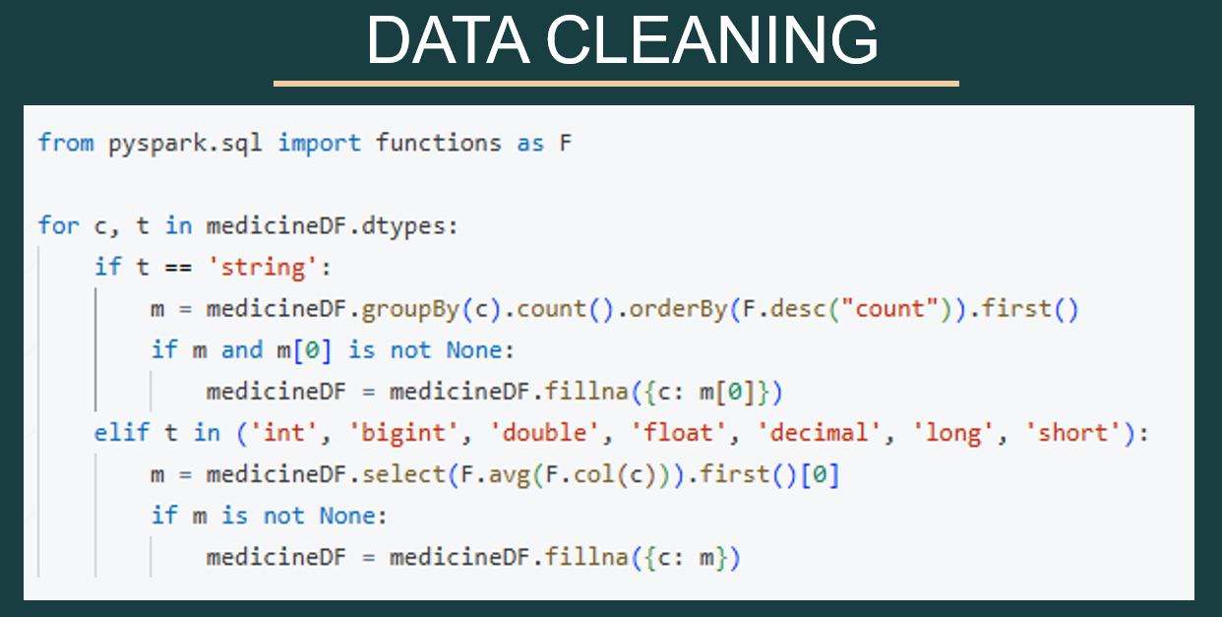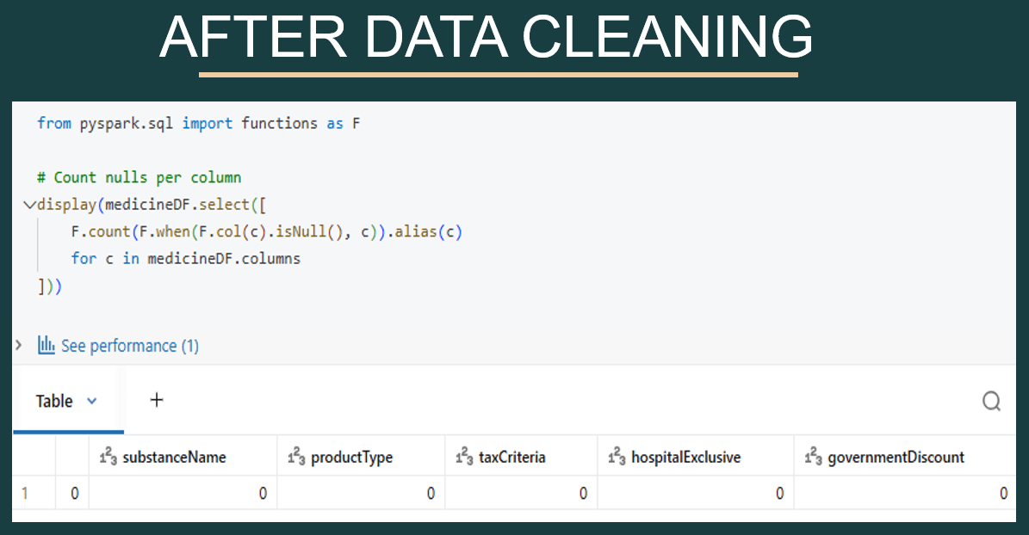

Pyspark RDD:

User story:
Categorize patients by gender and birthdate into Young, Adult, MidAge, or Elder male/female groups.

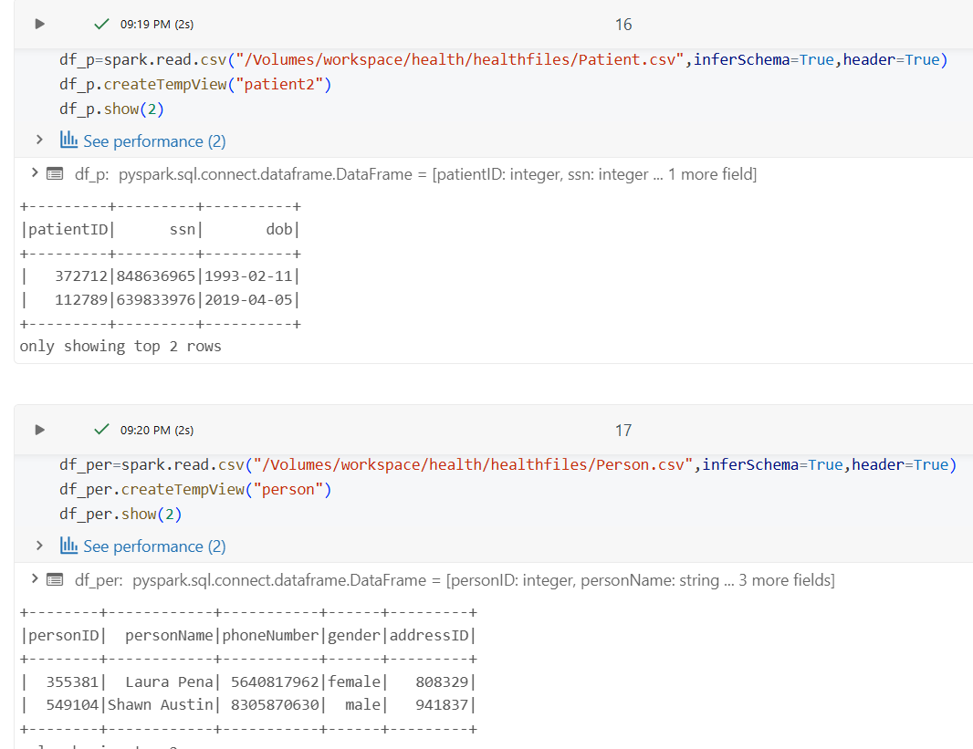
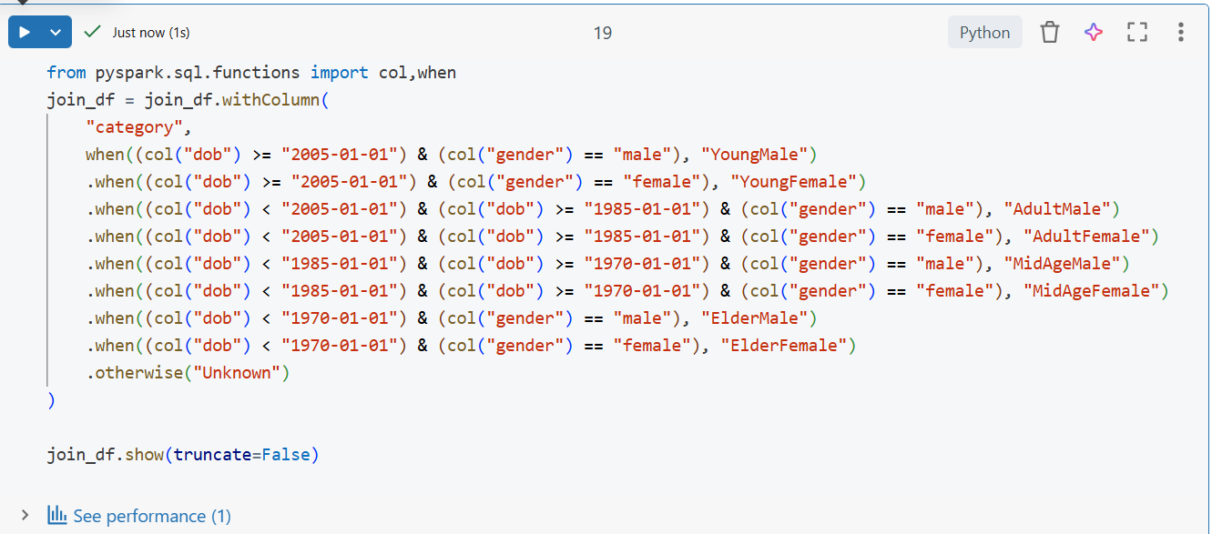
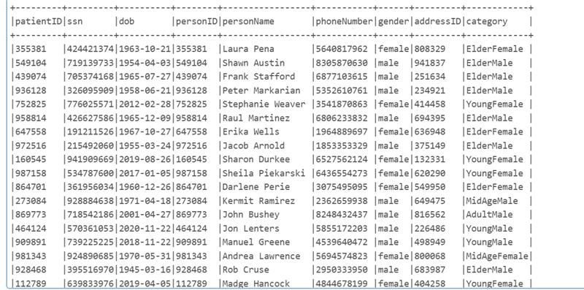

User Story :
Find the 3 cities with the lowest pharmacy-to-prescription ratio where prescriptions are more than 100.
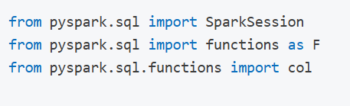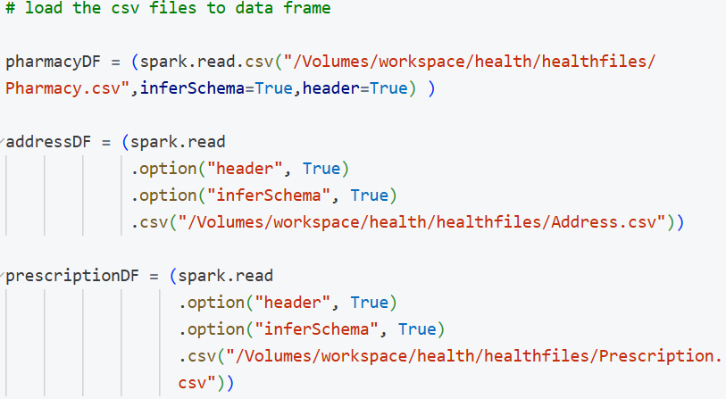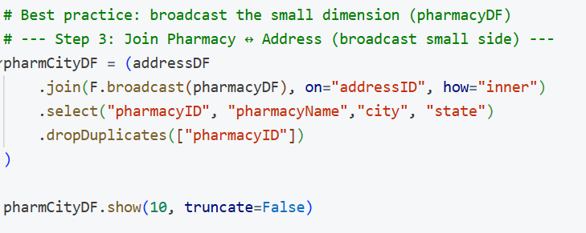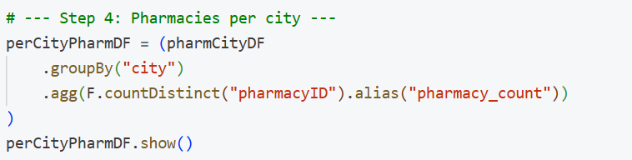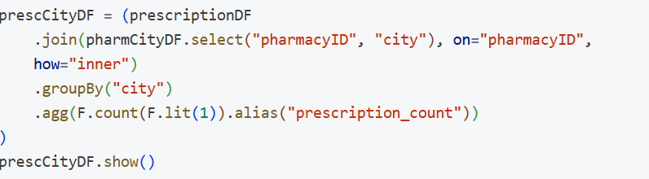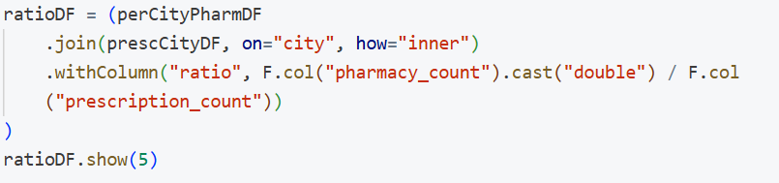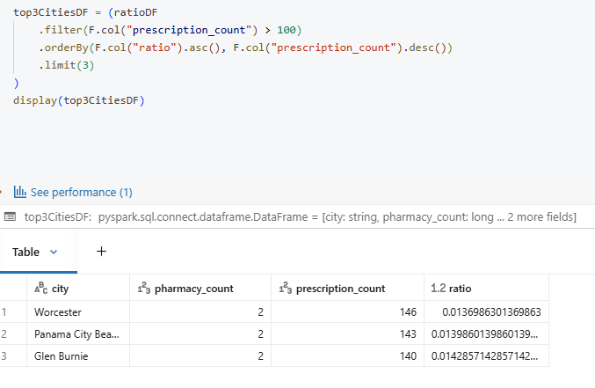

User Story 3:
“Which insurance plan is most and least claimed for each disease?”
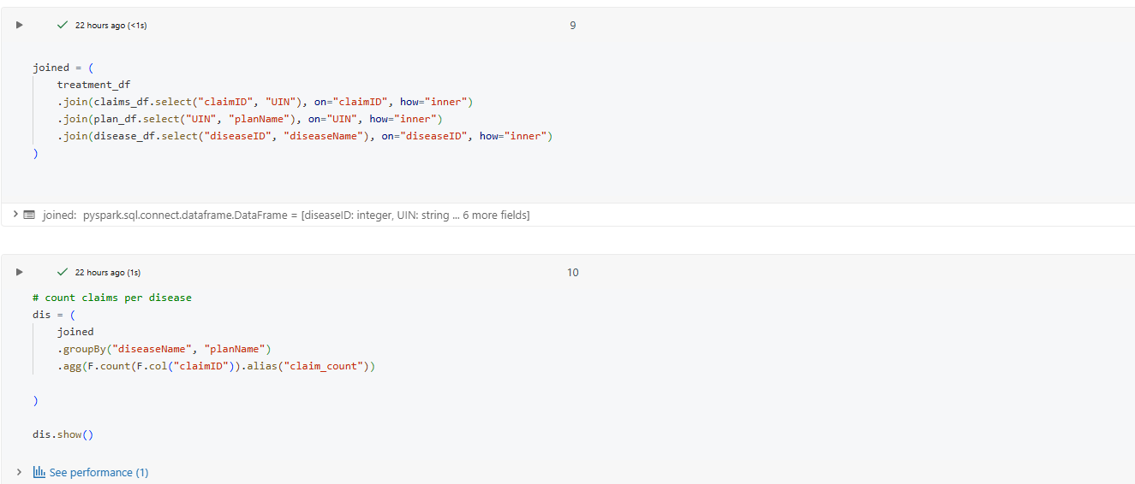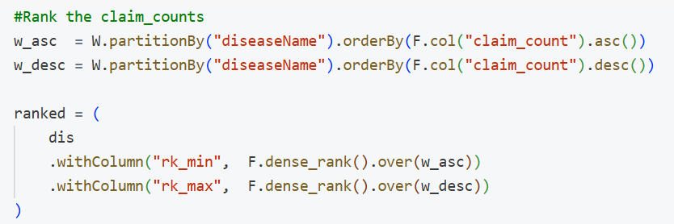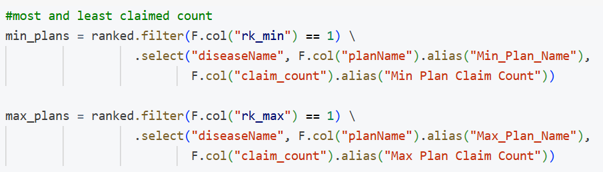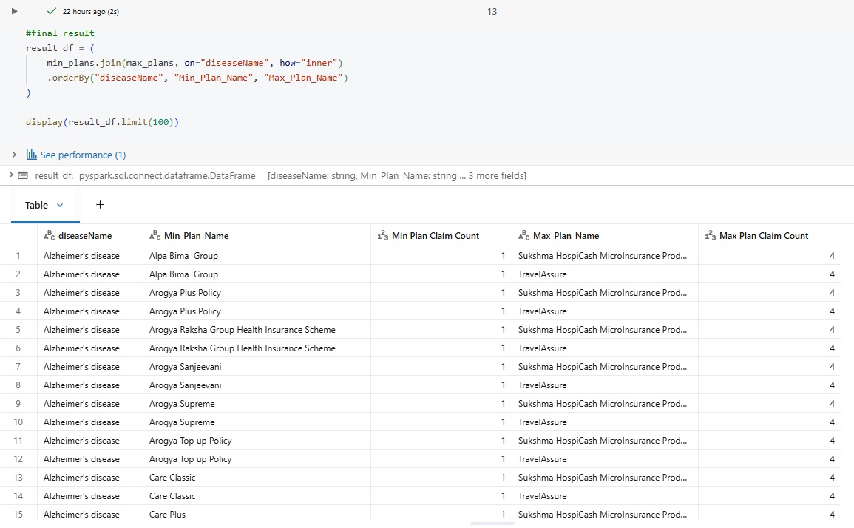

Spark RDD

User Story :
“What is the state‑wise treatments to claims ratio from 1 Apr 2021 to 31 Mar 2022?”
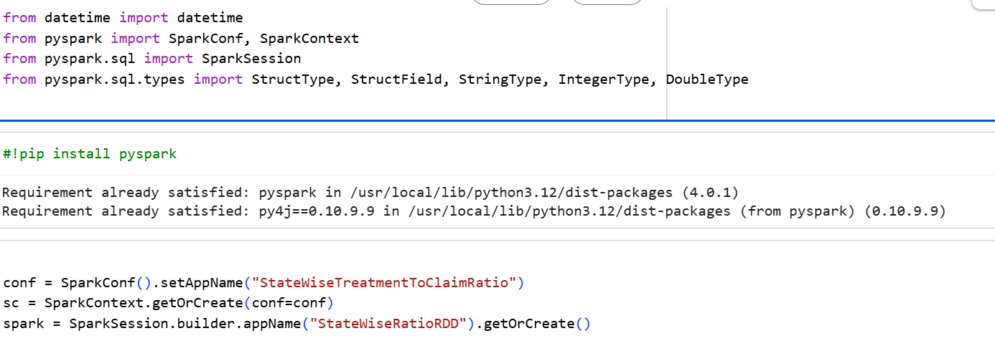
Date format
